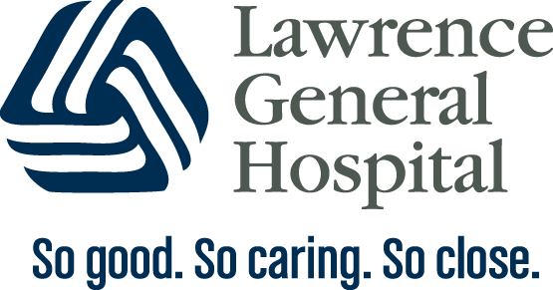

Lawrence General Hospital’s
Covid- 19 Rooming-in Agreement

I understand that my Covid-19 results are pending or positive, and I have been educated on the known symptoms. Considering the benefits of bonding with my baby against the unknown risks of Covid-19 on my baby, I have chosen to keep my infant with me rather than separated from me after a discussion with my health care team.

I understand that the following measures should be used to keep my baby safe:
- If I choose skin to skin, I will wear a mask and wash my hands and chest prior to holding the baby.
- If there is not a healthy care giver to provide newborn care, I will wear a mask and wash my hands and breasts (if breastfeeding) with soap and water when providing care to my baby.
- Keep my baby in the crib or bassinet at least 6 feet away from me when I’m not feeding or caring from him/her.
- If I’m pumping my breastmilk, I will wash the pump and tubing with disinfecting wipes and all the other pieces in soap and water before using again.

I will continue to do all of these things while I have symptoms or remain Covid-19 positive. I understand that I should have a negative Covid-19 test or consult with my physician before I am considered Covid-19 free.

______________________________ _______________
Signature of Mother Date and time

______________________________ _______________
Signature of Physician Date and time

______________________________ _______________
Interpreter (if needed) Date and time

April 22, 2020

